 | Hkkjrh; izksS|ksfxdh laLFkku xqokgkVh  Indian Institute of Technology Guwahati  Guwahati 781 039, India

Chairman, Students’ Welfare Board

 | Name | Period
 | Name | From | To
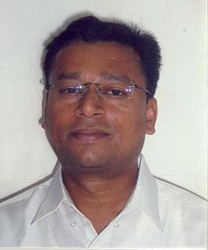 | Dr. S.R.M. Prassanna,  ECE | 04/01/2007 | 03/01/2009
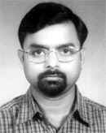 | Prof. D. C. Dalal,  Mathematics | 19/06/2009 | 30/06/2013
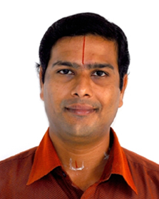 | Dr. K. Pakshirajan,  Biotechnology | 01/07/2013 | 30/06/2015

